

**Submitted by : Spogmai Jan**

**Roll no : 2430 - 0081**

**Submitted to : Sir Bilal**

**Subject : Object Oriented Programming**

**Lab task 02**

TASK 1:

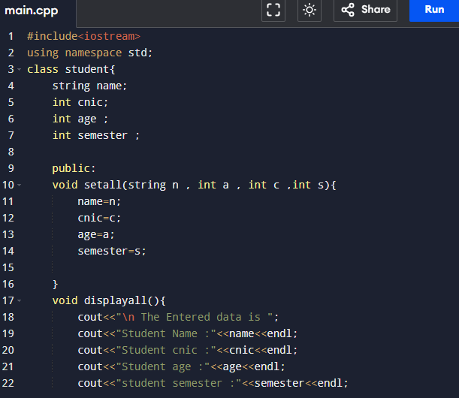

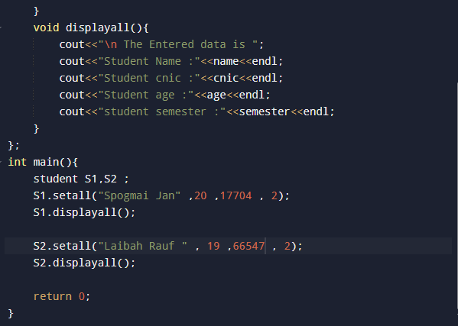

OUTPUT

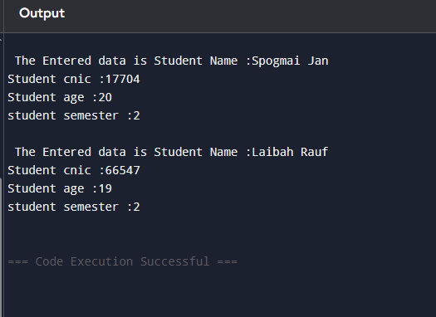

TASK 02:

BANKACCOUNT CLASS

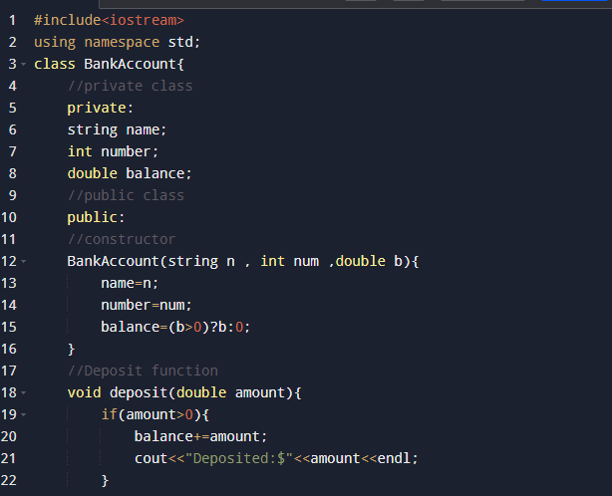

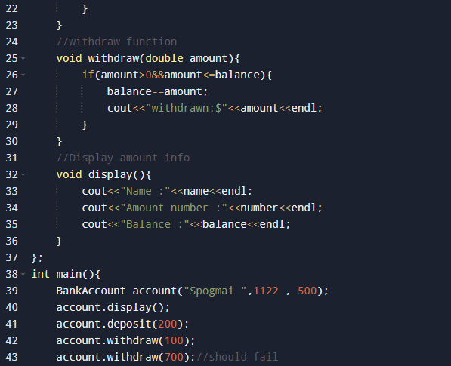

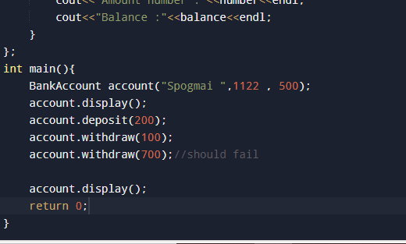

Output:

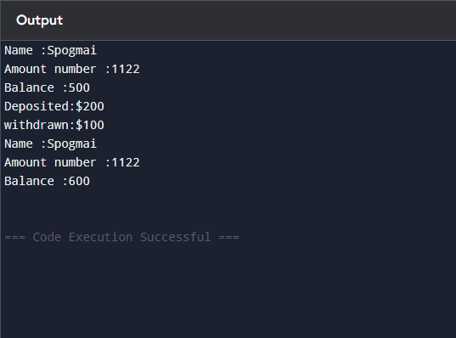

**------The End-----**